Using Satellite Images to Predict House Prices

Introduction
Using satellite imagery to investigate questions in social science is a promising and increasingly practical approach.
Traditional hedonic pricing models rely exclusively on structural attributes of the property itself—number of rooms, floor area, year built, condition, and so on—and fail to capture the visual character of the surrounding neighborhood: the quality of adjacent buildings, streetscape greenery, lot density, proximity to open space, and other contextual cues that a human buyer would absorb at a glance. Chopra et al. (2007) formalized this intuition by introducing a latent “desirability” manifold that varies smoothly over space, demonstrating that house prices depend not only on property-specific features but also on the unobserved spatial context of the neighborhood. Satellite imagery offers a complementary and scalable way to encode such spatial context directly from visual data.
I follow and extend the Feature-plus-Image (F+I) framework introduced by Semnani and Rezaei (2021), who showed on Los Angeles County data that augmenting tabular property features with Inception v3 image embeddings from Google Static Maps tiles improved R² by roughly 10 percentage points over a features-only baseline. Earlier, Bency et al. (2017) demonstrated that CNN features extracted from satellite imagery at multiple spatial scales could be combined with a Spatial Auto-Regressive (SAR) model to reduce RMSE by 57% compared to SAR alone, establishing that deep image features capture neighborhood information that traditional spatial models miss.
Our contribution is twofold: (1) I apply the F+I framework to Washington, DC using freely available government data; (2) I compare three pretrained image encoders—Inception v3, ConvNeXt V2, and DINOv2—to evaluate whether modern self-supervised vision representations improve price prediction.
Results indicate that satellite imagery significantly enhances predictive power. A LightGBM model trained on concatenated tabular features and Inception v3 embeddings achieved the highest overall performance with an $R^{2}$ of 0.870, a 13-percentage-point improvement over the tabular-only baseline. Among neural network architectures, the ConvNeXt V2 encoder achieved the lowest Mean Absolute Error at $184,240. The findings suggest that for medium-sized datasets, sample-efficient tree-based models can more effectively exploit high-dimensional image features than standard multi-layer perceptron fusion heads. This research demonstrates that publicly available aerial orthophotography provides a scalable, objective proxy for neighborhood desirability that traditional mass appraisal records lack.

Data
All data used in this project are publicly available from the DC Open Data portal (https://opendata.dc.gov/). I use three primary data sources—the CAMA tabular records, the Common Ownership Lots polygon geometries, and the DC aerial orthophotography—and train on sales from six imagery years (2015, 2017, 2019, 2021, 2023, 2025).

Tabular Data: CAMA Residential, Commercial, and Condominium
https://opendata.dc.gov/datasets/DCGIS::computer-assisted-mass-appraisal-residential/about
The Computer Assisted Mass Appraisal (CAMA) datasets contain detailed property-level attributes for all parcels in Washington, DC. Each record includes the sale price and date, structural features (gross building area, land area, number of bedrooms, bathrooms, rooms, stories, fireplaces, kitchens, number of units), construction details (year built, year remodeled, effective year built), and categorical descriptors (heating type, air conditioning, architectural style, structure type, grade, condition, exterior wall material, roof type, interior wall type, use code).
I retain only qualified sales (arm's-length transactions) with a positive sale price. Each property is identified by its SSL (Square/Suffix/Lot), the standard DC parcel identifier. Commercial and condominium records use LIVING_GBA in place of GBA; I rename this column for consistency. Not all features are available across property types (e.g., commercial properties lack BATHRM, BEDRM, ROOMS); missing features are filled with zero rather than imputed, since the missingness is structural. A PROP_TYPE categorical feature (residential, commercial, condominium) is added so the model can learn type-specific pricing patterns.

Spatial Data: Common Ownership Lots
https://opendata.dc.gov/datasets/DCGIS::common-ownership-lots/about
The Common Ownership Lots GeoJSON dataset provides polygon geometries for every tax lot in DC. I join this dataset to the CAMA records on the SSL field to obtain geospatial boundaries for each property. These boundaries define the bounding box used to request satellite image chips.

Satellite Imagery: DC Aerial Orthophotography
https://opendata.dc.gov/pages/dc-from-above
Washington, DC publishes ultra-high-resolution aerial orthophotography through its “DC from Above” program. The imagery is captured at 3-inch (0.08 m) per-pixel resolution. I access the imagery programmatically via the ArcGIS ImageServer REST API, which accepts a geographic bounding box and returns a PNG image chip at the native resolution. Available imagery years include 2015, 2017, 2019, 2021, 2023, and 2025.
For each property, I compute the lot bounding box from its polygon geometry, add a 20-meter buffer to capture surrounding neighborhood context (street, adjacent buildings, greenery), and request the corresponding image chip capped at 1024 pixels. This procedure yields one image per lot per year. In total, I collect image chips for six imagery vintages across all merged properties.

Method

Data Preparation
The data preparation proceeds as follows:
- Load and merge. I load the Common Ownership Lots GeoJSON and the three CAMA CSV files (residential, commercial, condominium), normalize SSL identifiers (collapsing whitespace), assign a PROP_TYPE label to each record, rename LIVING_GBA to GBA for commercial and condominium records, filter to qualified sales with price > 0, and perform an inner join on SSL. The result is a GeoDataFrame with both property attributes and lot geometries.
- Fetch image chips. For each lot in the merged dataset, I compute its buffered bounding box in UTM coordinates, convert to WGS84, and query the DC ArcGIS ImageServer for each available year. Images are saved as <ssl>.png under data/images/<year>/.
- Temporal filtering. For each imagery year, I define a sale window of plus or minus 3 months around the orthophoto collection (flight) date. For example, the 2023 orthophoto was flown on May 8, 2023, so I retained sales between February 8 and August 8, 2023. This ensures temporal alignment between the image and the sale event across all six years.

Feature Engineering
I use 14 numeric features and 12 categorical features, for a total of 26 tabular predictors:
- Numeric: BATHRM, HF_BATHRM, ROOMS, BEDRM, AYB (actual year built), YR_RMDL (year remodeled), EYB (effective year built), STORIES, GBA (gross building area), LANDAREA, NUM_UNITS, KITCHENS, FIREPLACES, SALE_YEAR (derived from SALEDATE to capture temporal market conditions).
- Categorical (integer-encoded): HEAT, AC, STYLE, STRUCT, GRADE, CNDTN, EXTWALL, ROOF, INTWALL, USECODE, QUALIFIED, PROP_TYPE (residential, commercial, or condominium).
Numeric features missing due to property type differences (e.g., commercial properties lack BATHRM) are filled with zero rather than the column median, since the missingness is structural. Numeric features are then standardized (zero mean, unit variance) using StandardScaler. The regression target is log(1 + price), which is further standardized to approximately N(0,1) using a separate StandardScaler fitted on the combined training data. This label normalization makes the MSE loss better-behaved and the fusion layer's linear output more natural. At inference, predictions are inverse-transformed back to dollar space.

Image Encoders
I extract fixed image embeddings using three pretrained convolutional and transformer encoders, all with their weights frozen (no fine-tuning of the encoder itself):
- Inception v3: ImageNet-pretrained on ~1.28M labeled natural images, classification head removed. Input resized to 299×299. Produces a 2048-dimensional embedding per image.$299×299$
- $299×299$ConvNeXt V2: A modern convolutional architecture (Woo et al., 2023) pretrained with a fully convolutional masked autoencoder self-supervised objective and then fine-tuned on ImageNet-22K. I use the Base variant. Input resized to 224×224. Produces a 1024-dimensional embedding per image.
- $299×299$DINOv2: A self-supervised vision transformer (Oquab et al., 2023) trained on a curated 142M-image dataset using a self-distillation objective with no labels. I use the ViT-B/14 variant. Input resized to 224×224. Produces a 768-dimensional embedding per image.

F+I Model Architecture
I adopt the Feature-plus-Image (F+I) architecture from Semnani and Rezaei (2021). The model consists of two branches fused by concatenation:
- Image branch: embedding_dim → 512 → 64 (two fully connected layers with ReLU activation and dropout 0.3/0.2).$d_{emb}→512→64$
- Feature branch: 26 → 64 (one fully connected layer with ReLU and dropout 0.2).$n_{features}→64$
- Fusion head: 128 → 64 → 1 (concatenation of the two 64-dimensional branch outputs, followed by two FC layers).$128→64→1$
The model is trained with the Adam optimizer (learning rate 0.0005), L2 weight decay of 0.1, and a per-batch exponential learning rate decay: lr_new = lr * 1/(1 + alpha * batch_number) with alpha = 0.0001, following the schedule described in the original paper. I train for 200 epochs with a batch size of 1024 and use MSE loss on the standardized log-price target. The data are split 90%/5%/5% into train, validation, and test sets. I retain the model checkpoint with the lowest validation MSE and report results on the held-out test set.
I evaluate performance using R² in both log-price and dollar space, along with mean absolute error (MAE) in dollars:$R^{2}$
$R^{2}=1-\frac{\sum_{i}{}(y_{i}-{\hat{y}}_{i})^{2}}{\sum_{i}{}(y_{i}-y‾)^{2}}$

GBM on Concatenated Embeddings
As an alternative to the neural network fusion head, I also evaluate a gradient boosting approach. Instead of training an MLP to compress the 2,048-dimensional image embeddings down to 64 dimensions, I concatenate the raw embeddings directly with the 26 tabular features, producing a 2,074-dimensional feature vector per property. This vector is then fed to a LightGBM regressor.
This approach sidesteps the neural network's data hunger: tree-based models are more sample-efficient for tabular data and can naturally select which of the 2,048 embedding dimensions are informative without requiring gradient-based training of the image branch. LightGBM is trained with 2,000 boosting rounds (early stopping after 50 rounds without improvement), learning rate 0.05, 127 leaves, feature fraction 0.6, and bagging fraction 0.8. The target is log(1 + price) without additional standardization, as tree-based models are invariant to monotonic feature transformations. The same 90%/5%/5% train/validation/test split is used for comparability with the F+I models.

EDA Results
The combined dataset contains 8,896 qualified sales across six imagery years (2015–2025), drawn from residential (51,363), commercial (3,324), and condominium (36,274) CAMA records. Per-year sample counts after merging with lot geometries are: 2025 (1,551), 2023 (1,624), 2021 (2,141), 2019 (1,468), 2017 (1,150), and 2015 (962).
The median sale price across all years is $850,000, with a mean of $1.52M driven by extreme outliers (max $307M). The interquartile range is $564K–$1.27M. The log-price distribution is approximately normal, confirming the appropriateness of the log(1 + price) transformation. Price per square foot has a median around the typical DC level, with a long right tail from high-value properties.
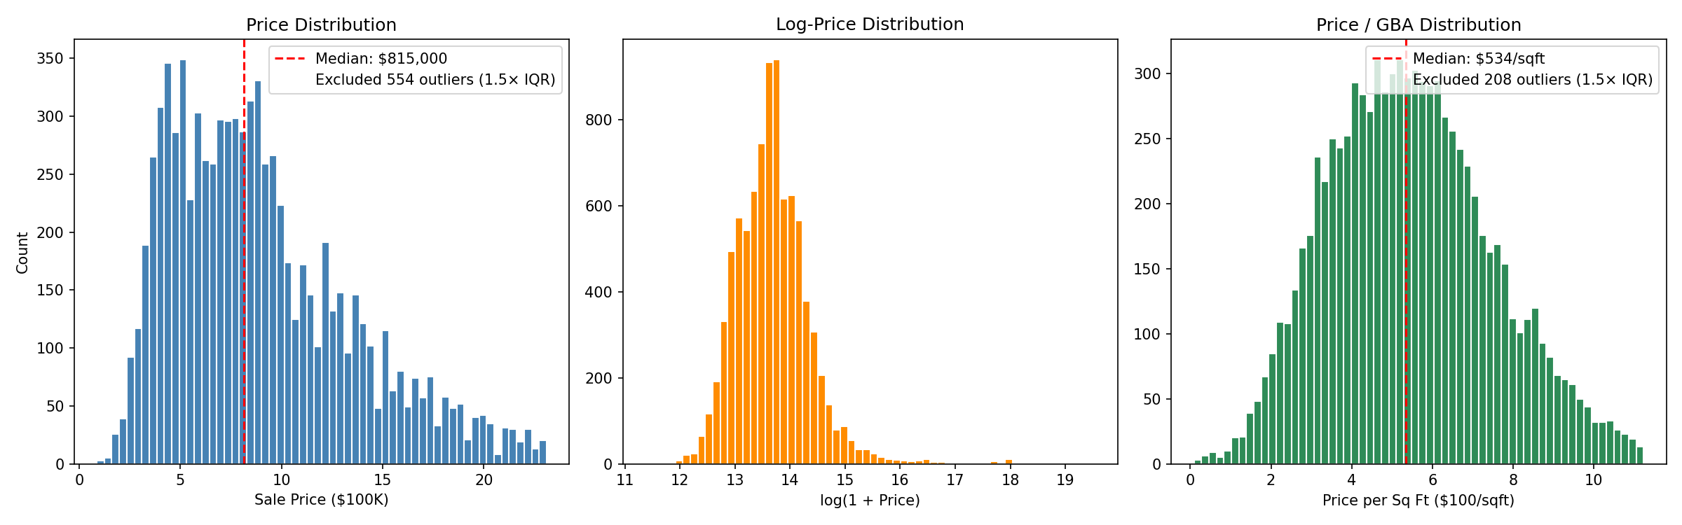
Figure 1. Distribution of sale price (raw, log-transformed, and per-square-foot). The log-price distribution is approximately normal, motivating the log(1 + price) target.
Key structural features show expected distributions: median GBA is 1,550 sqft, median lot area is 2,138 sqft, median 3 bedrooms and 2 bathrooms. The most common structure type is Row Inside (3,594), followed by Single (2,176) and Semi-Detached (1,321), reflecting DC's characteristic rowhome stock. Most properties are graded Average (2,915) or Above Average (2,508) in Good (4,429) or Very Good (2,228) condition.
The correlation heatmap reveals strong positive correlations between PRICE and GBA (r = 0.56), BATHRM (r = 0.47), and ROOMS (r = 0.41). The cross-year comparison shows a clear upward price trend from 2015 to 2025, motivating the inclusion of SALE_YEAR as a temporal feature. The spatial price map shows the expected geographic pattern: highest prices in northwest DC (Georgetown, Kalorama, Massachusetts Avenue Heights) with lower prices in the eastern quadrants. Sample image chips with the 20-meter buffer show surrounding neighborhood context including adjacent buildings, streets, and tree canopy.
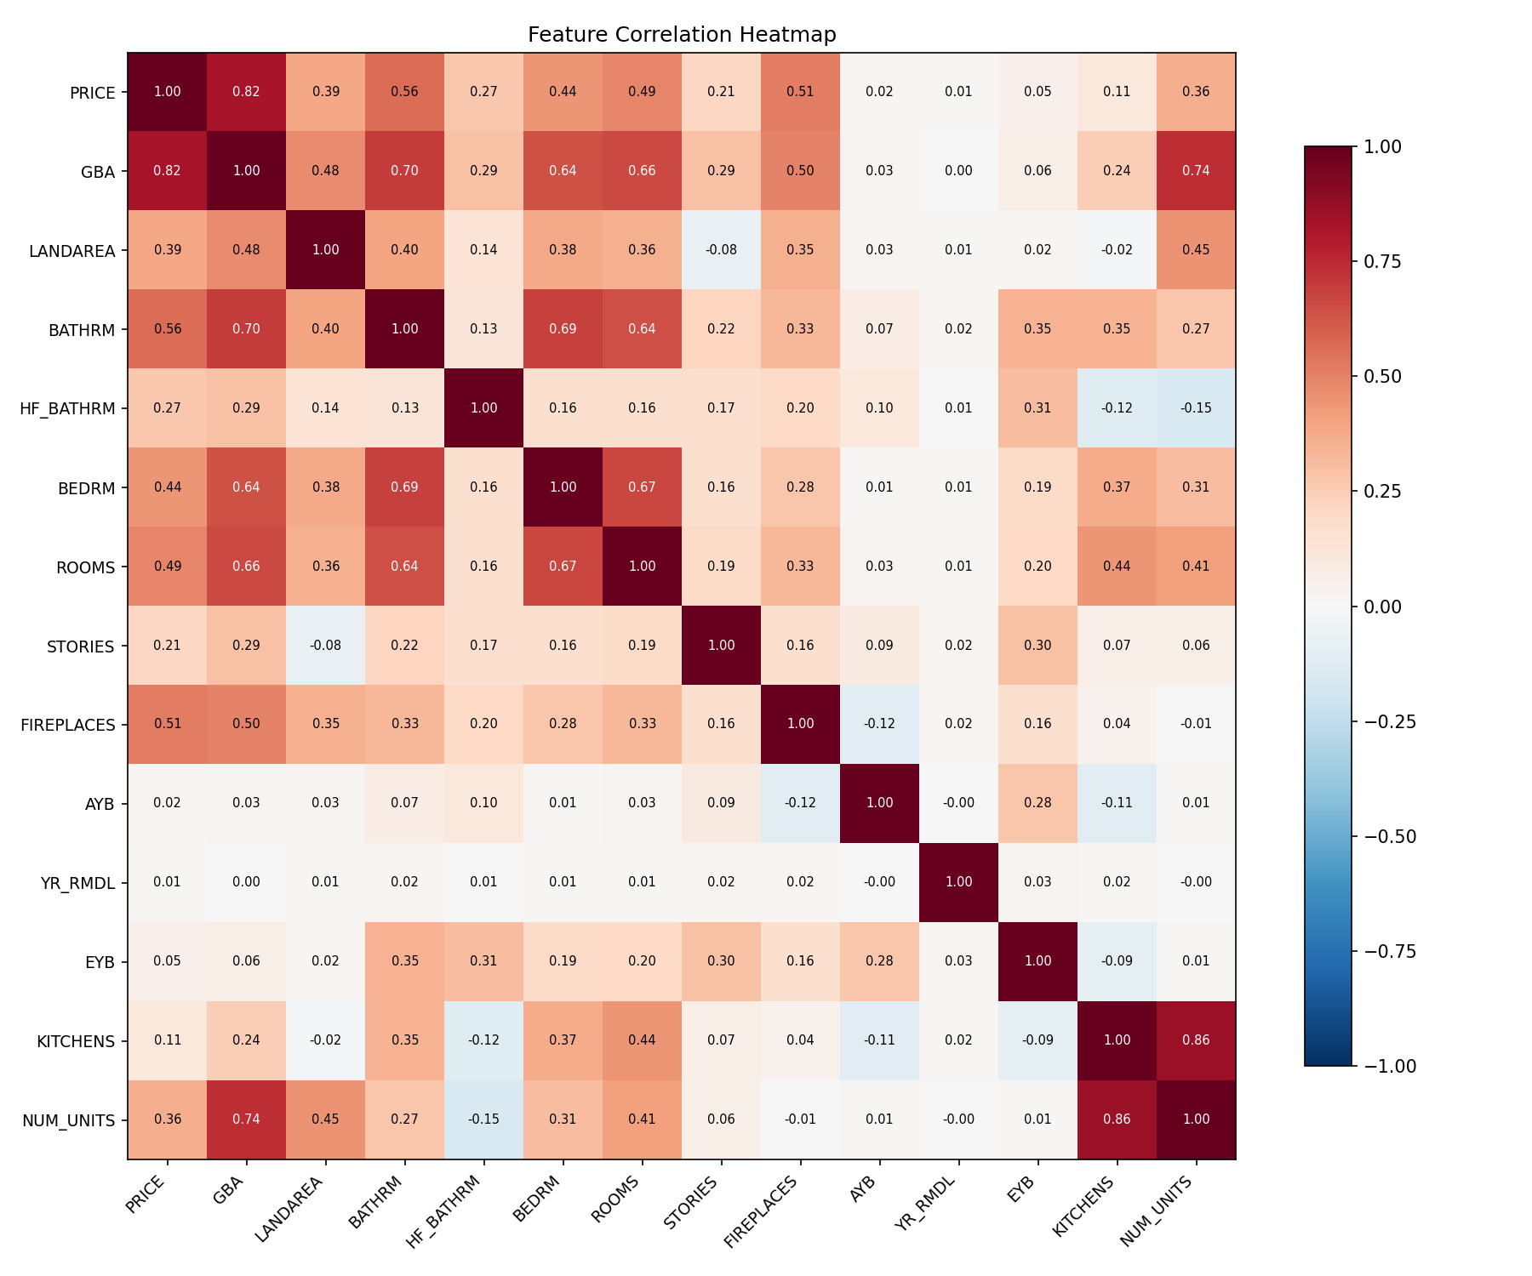
Figure 2. Correlation heatmap of numeric features. PRICE is most strongly correlated with GBA (r = 0.56), BATHRM (r = 0.47), and ROOMS (r = 0.41).
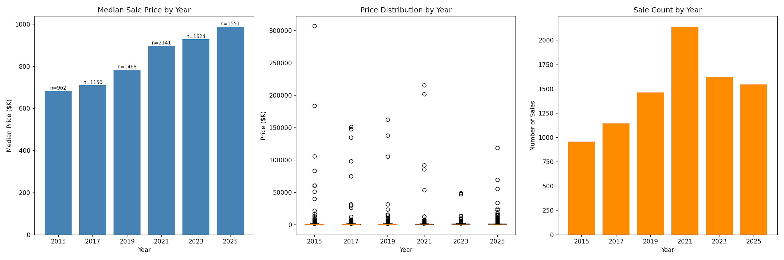
Figure 3. Cross-year price comparison. Median sale price trends upward from 2015 to 2025, motivating the inclusion of SALE_YEAR as a temporal feature.
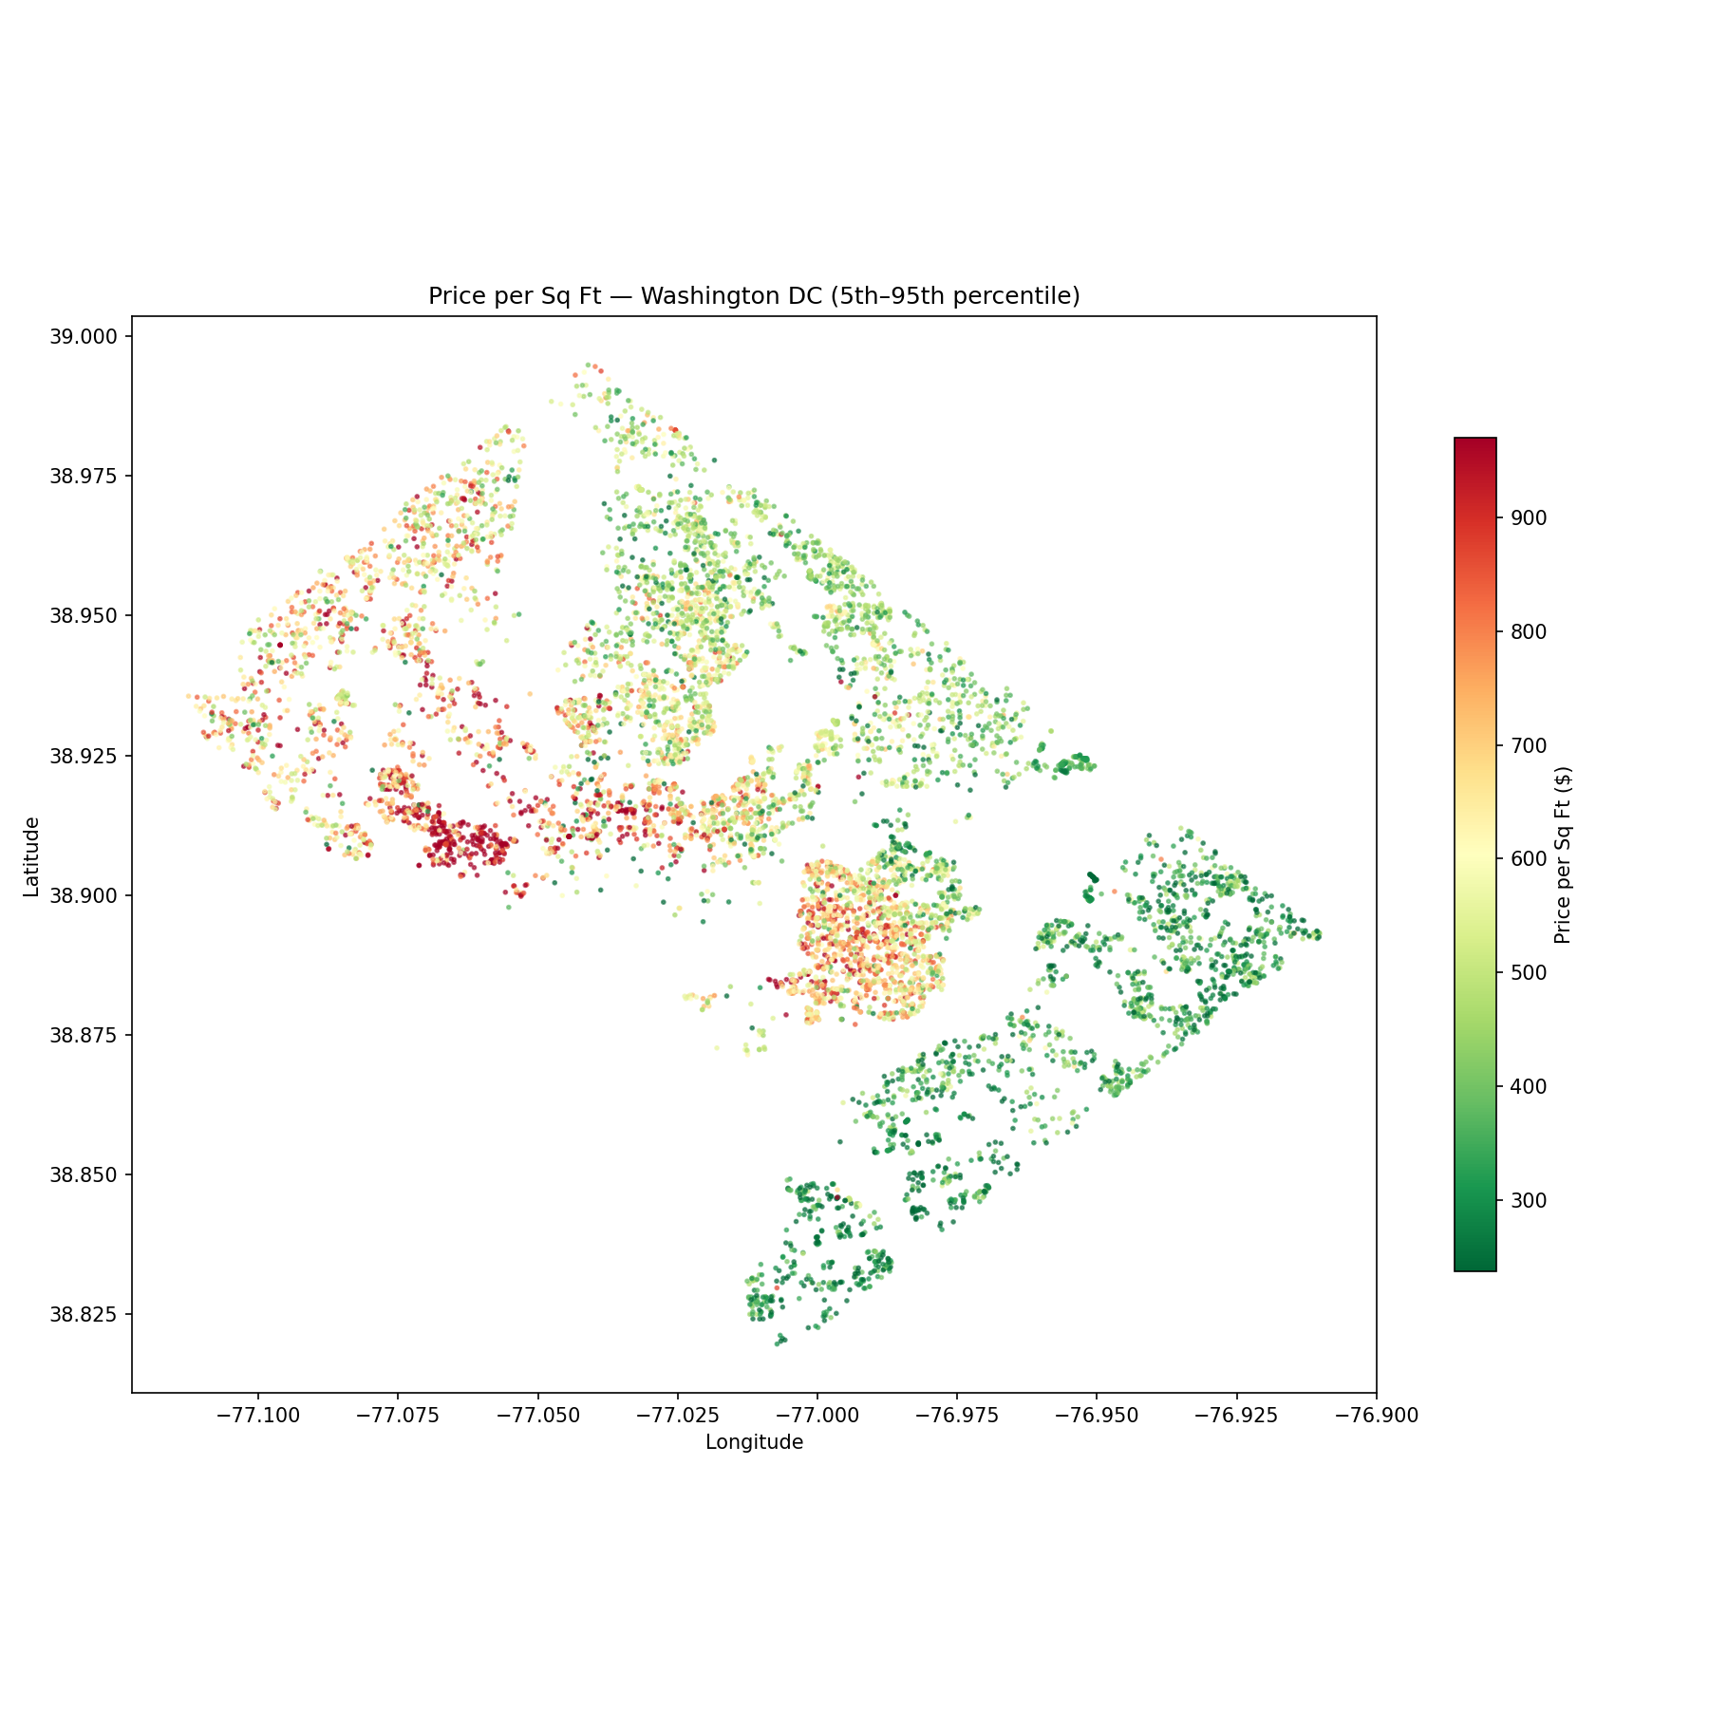
Figure 4. Price per square foot, clipped to the 5th–95th percentile. The expected geographic pattern emerges: highest values in northwest DC, lower values in the eastern quadrants.

Primary Results
I evaluate all models on a held-out test set of 445 samples (5% of the combined 8,896-sample dataset), using the same random split (random_state=42) across all experiments for comparability. The table below summarizes performance across baseline models, the F+I neural network with all three image encoders (Inception v3, ConvNeXt V2, DINOv2), and a LightGBM regressor on concatenated tabular plus Inception v3 image features.
Model | R² (log) | R² ($) | MAE ($)
Linear regression | 0.665 | -10.119 | $1,386,441
Ridge regression | 0.665 | -10.111 | $1,386,183
Lasso regression | 0.665 | -3.812 | $1,116,163
Random forest | 0.892 | 0.602 | $436,009
Gradient boosting (sklearn, tabular only) | 0.904 | 0.737 | $343,434
F+I Inception v3 | 0.765 | 0.218 | $633,273
F+I ConvNeXt V2 | 0.810 | 0.719 | $184,240
F+I DINOv2 | 0.834 | 0.298 | $568,234
LightGBM (embeddings + tabular) | 0.909 | 0.870 | $297,319
These results suggest that for small-to-medium datasets, tree-based models trained on raw concatenated embeddings are competitive with—and in this case outperform—neural-network fusion architectures at combining high-dimensional image features with tabular data. The LightGBM approach achieves R²($) of 0.870, which is 13 percentage points higher than the tabular-only gradient boosting baseline (0.737), demonstrating that satellite image features add value when the learning algorithm can efficiently exploit them. A more nuanced comparison with the F+I models is provided in Stage 4: while LightGBM dominates Inception v3 (R²($)=0.218) by 65 points, the gap shrinks to 15 points against ConvNeXt V2 (0.719), and ConvNeXt V2 attains the lowest MAE ($184K) of any model.
The negative R²($) on the linear models (-10.1 for Linear/Ridge, -3.8 for Lasso) is explainable that these models are fit on log-price, where they reach R²(log)=0.665, but when predictions are inverse-transformed back to dollars a small log-space residual on the largest sales (e.g. a $50M record) blows up.

Evaluation

Our result is consistent with the broader literature showing that DINOv2-style self-supervised features transfer better to non-classification tasks than ImageNet classification features. The single best model overall is LightGBM, which improves on the tabular-only gradient-boosting baseline by 13 percentage points, which measures how much value the satellite imagery adds beyond what the CAMA tabular records already encode.
One direct explanation for this improvement is that the visual content of a 20-meter-buffered aerial photo around a parcel carries pricing-relevant information that the structural CAMA fields do not. Plausibly this signal includes the quality of neighboring buildings, street character, tree canopy, and lot density. These are things that a human appraiser would notice but that are absent from a row of CAMA columns.
The reason for the LightGBM on the raw concatenated embeddings outperforming the F+I MLP architecture from the original paper could be a small amount of training data. With only ~8K training samples, the MLP under-fits the high-dimensional input and the tree-based model that is more sample-efficient and can natively select informative dimensions wins.
Our research also has three places that could need improvement. (1) The 90/5/5 split leaves only 445 test samples, which could be too small to capture the character of the dataset to be the test set, but we have to do this due to the limited data . (2) The IID random split does not test temporal generalization: in a real deployment we would predict 2025 sales using only 2015–2023 data, and a purely random split lets information leak across years. (3) The image encoders are frozen; fine-tuning even the last few blocks could lift the F+I numbers, at the cost of more compute and overfitting risk on this dataset size.

Summary

By applying the Feature-plus-Image (F+I) framework to 8,896 qualified sales from 2015 to 2025, this research evaluates the predictive power of modern image encoders, showing that satellite imagery effectively captures vital neighborhood context—such as street character, adjacent building quality, and tree canopy—that standard structural datasets omit. The LightGBM model, trained on a concatenation of tabular features and raw Inception v3 embeddings, emerged as the top performer. It achieved an R² of 0.870 in dollar space, which improved upon the tabular-only gradient boosting baseline by 13 percentage points.
Furthermore, the findings reveal that for small-to-medium datasets, tree-based models can be more sample-efficient than neural network fusion architectures. Because the dataset was limited to roughly 8,000 training samples, the Multi-Layer Perceptron (MLP) struggled to fit the high-dimensional input, whereas LightGBM natively and efficiently selected informative dimensions. Among the neural network F+I models, ConvNeXt V2 delivered the strongest results, achieving the lowest Mean Absolute Error (MAE) of $184,240.
Methodologically, a few natural extensions stand out for future work. First, implementing a temporal holdout—training on 2015–2023 data and testing on 2025 sales—would better reflect how this model would actually be deployed in the real world. Second, incorporating multi-scale image inputs, such as combining a tight 20-meter crop with a wider 200-meter view as done by Bency et al. (2017), would allow the model to capture both the specific lot and the broader neighborhood context.
Beyond those next steps, this project highlighted two key takeaways. First, sample size is a major bottleneck when working with neural network architectures. Second, evaluation metrics can be misleading if viewed in isolation. For instance, reporting only log-space R² makes linear and ridge regressions look respectable (0.665), even though their predictions are catastrophically off in actual dollar space. Conversely, relying only on dollar-space R² hides just how well-calibrated DINOv2 is in log space. Ultimately, reporting multiple metrics side by side is essential to avoid unfair or misleading model comparisons.

References

Ayalew, A. D., Demissie, M. B., & Gebremichael, S. T. (n.d.). Using satellite imagery and GIS for property tax assessment in developing countries.
Bency, A. J., Rallapalli, S., Ganti, R. K., Srivatsa, M., & Manjunath, B. S. (2017). Beyond spatial auto-regressive models: Predicting housing prices with satellite imagery. In Proceedings of the IEEE Winter Conference on Applications of Computer Vision (WACV).
Burke, M., Driscoll, A., Lobell, D., & Ermon, S. (2020). Using satellite imagery to understand and promote sustainable development (NBER Working Paper No. 27879). National Bureau of Economic Research.
Chopra, S., Thampy, T., Leahy, J., Caplin, A., & LeCun, Y. (2007). Discovering the hidden structure of house prices with a non-parametric latent manifold model. In Proceedings of the 13th ACM SIGKDD International Conference on Knowledge Discovery and Data Mining (pp. 173–182).
Das, S. S. S., Ali, M. E., Li, Y.-F., Kang, Y.-B., & Sellis, T. (2020). Boosting house price predictions using geo-spatial network embedding. arXiv. https://arxiv.org/abs/2009.00254
Khachiyan, A., Thomas, A., Zhou, H., Hanson, G. H., Cloninger, A., Rosing, T., & Khandelwal, A. (2021). Using neural networks to predict micro-spatial economic growth (NBER Working Paper No. 29569). National Bureau of Economic Research.
Kondile, P., Msomi, M. P., Moosa, B., & Okoro, C. (2025). Benefits and challenges of using satellite imagery for property valuation data collection. CIB Conferences, 1, Article 57.
Kucklick, J.-P., & Müller, O. (2023). Deep learning for real estate appraisal with satellite-based analysis. Journal of Business Analytics.
Oquab, M., Darcet, T., Moutakanni, T., Vo, H., Szafraniec, M., Khalidov, V., Fernandez, P., Haziza, D., Massa, F., El-Nouby, A., Assran, M., Ballas, N., Galuba, W., Howes, R., Huang, P.-Y., Li, S.-W., Misra, I., Rabbat, M., Sharma, V., … Bojanowski, P. (2023). DINOv2: Learning robust visual features without supervision. arXiv. https://arxiv.org/abs/2304.07193
Sellam, Z. A., Distante, C., Taleb-Ahmed, A., & Mazzeo, P. L. (2024). Boosting house price estimations with multi-head gated attention. arXiv. https://arxiv.org/abs/2405.07456
Semnani, S. J., & Rezaei, H. (2021). House price prediction using satellite imagery. arXiv. https://arxiv.org/abs/2105.06060
Woo, S., Debnath, S., Hu, R., Chen, X., Liu, Z., Kweon, I. S., & Xie, S. (2023). ConvNeXt V2: Co-designing and scaling ConvNets with masked autoencoders. In Proceedings of the IEEE/CVF Conference on Computer Vision and Pattern Recognition (CVPR).

The project can be accessed through the following link: https://drive.google.com/drive/folders/1-8AXKkcWBma_aeAuSkUUmYkiTw1MZDwu?usp=drive_link

